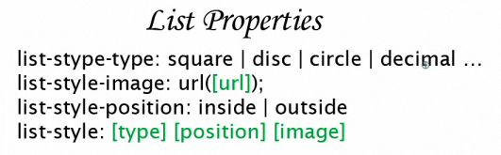

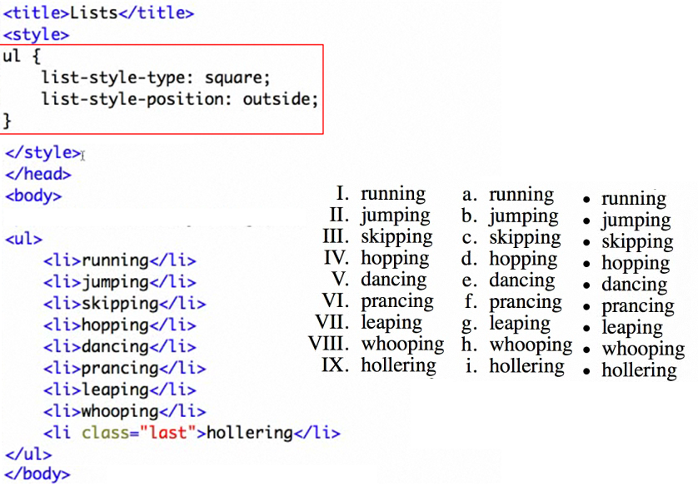

**Make a list display inline**

Use margin and padding setting

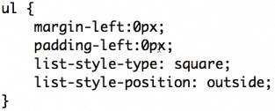

If you include, then it will show

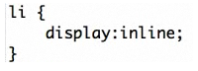



**Improving**

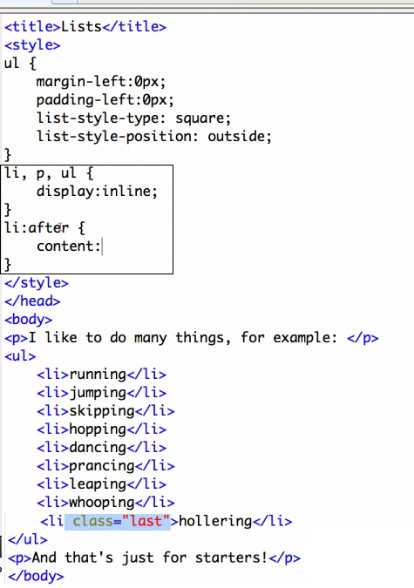



The last one (hollering) has a “,” to take out the comma you include

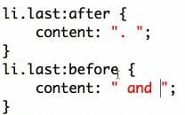



**Style a list so that it looks like navigational buttons**

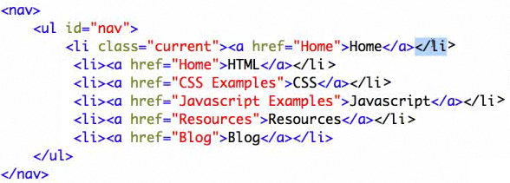

**Step 1 take away format of li and ul**

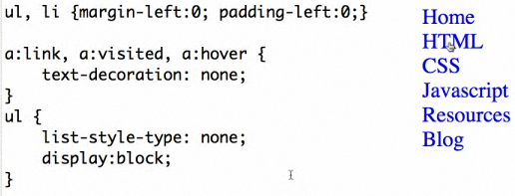

**Step 2 Horizontal**

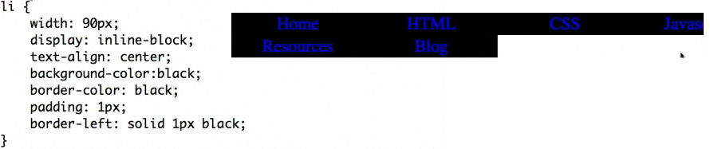

**Step 3 starting**

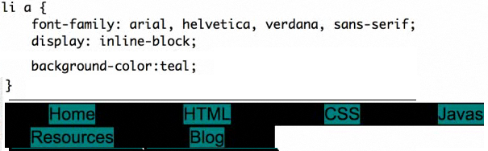

**Step 4 Button like**

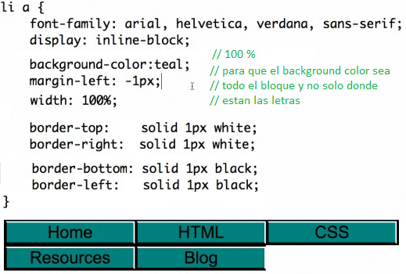

**CREATE DYNAMIC NAV MENUS WITH NESTED LISTS**

**OPTION 1: SHOW CHILDREN WHEN HOVERING THE NODES**

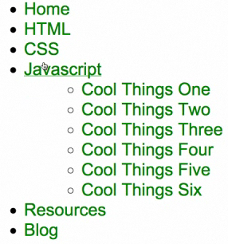

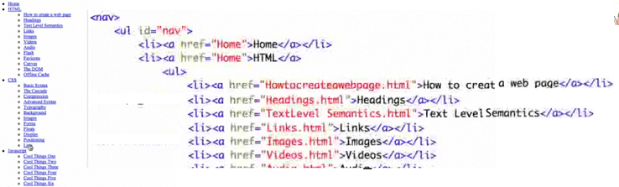

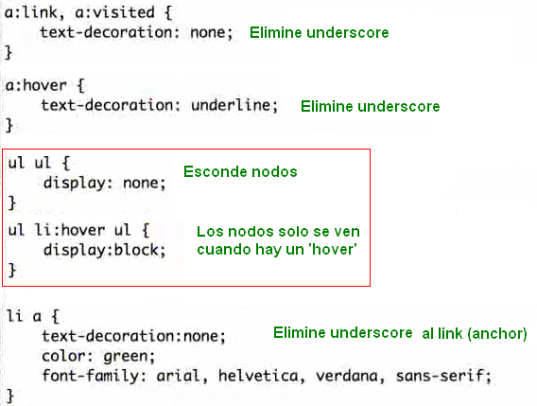

**OPTION 2**

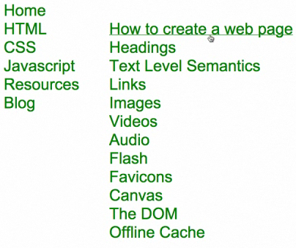

Create a dynamic nav menu using nested lists that puts sub-menus out of the way of the first level

Decorar, elimine underscored y los bullet points

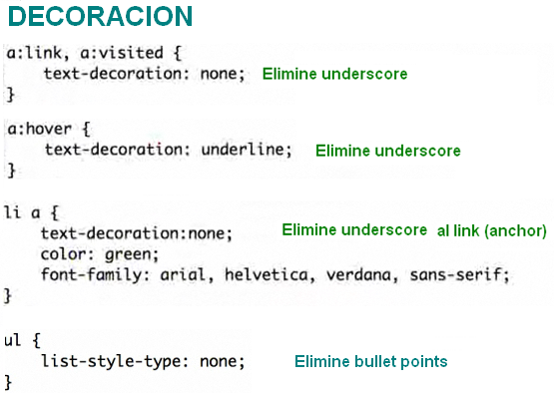

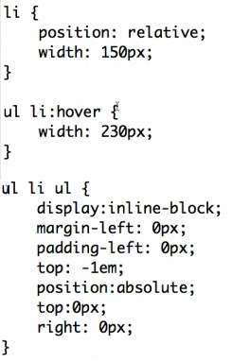

Display: none; hide the children

Display: block; shows children

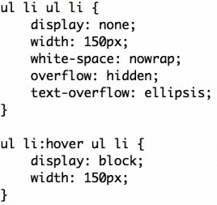

**OPTION 3: Horizontal Nav Menu**

Create a nav menu with drop-down sub-menus

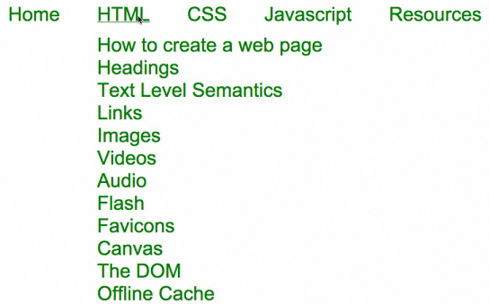

Keep decoration

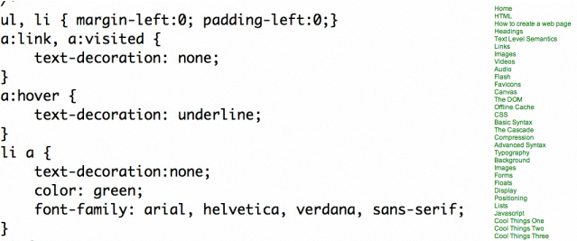

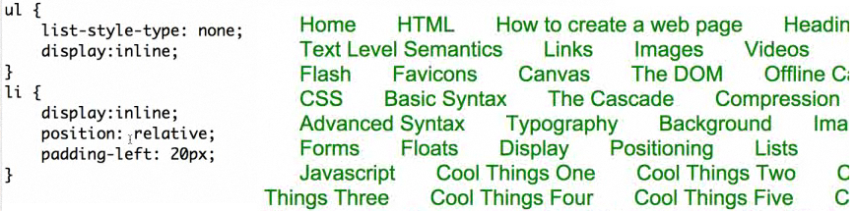

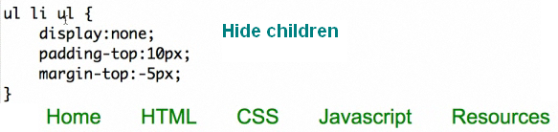

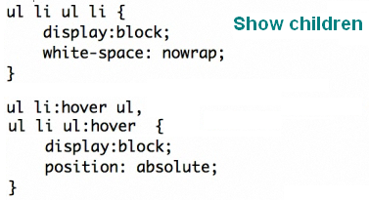

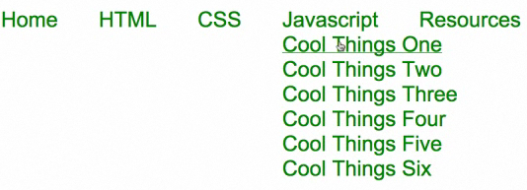

Para crear mas separacion entre el top menu y los sub menus agregue padding y margin

